**Chapter 4**

Design

**4.1 Entity Relationship Diagram**

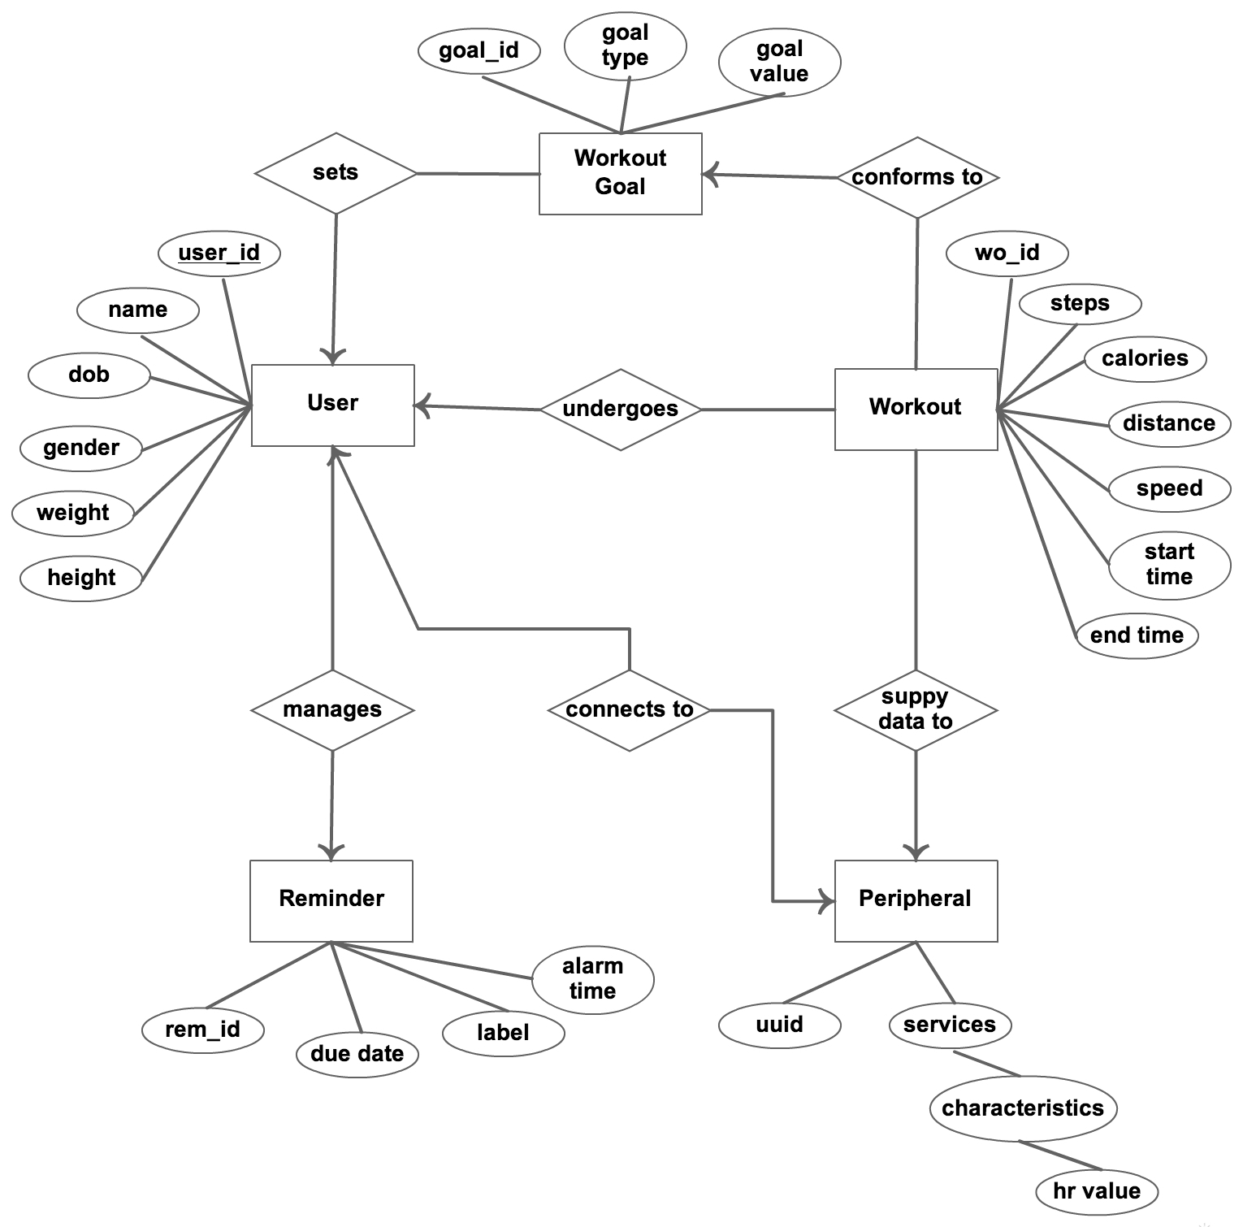

Figure 4.1: ER Diagram

* 1. **Data Dictionary**

1. **User_Details** - This table contains all the important information of user.

Table 4.1 : User_Details Schema

| Column Name | Data Type | Nullable | Description |
| --- | --- | --- | --- |
| user_id | integer (auto_incr) | N | Unique user identification |
| name | text | N | User’s name |
| dob | integer | N | Date of birth |
| gender | integer | N | Gender of user |
| height | real | N | User’s height in cm |
| weight | real | N | User’s weight in kg |
| hr_monitoring | integer | N | 0 = disable , 1 = enable |

1. **HR_Details**  - This table Stores Heart Rate data.

Table 4.2 : HR_Details Schema

| Column Name | Data Type | Nullable | Description |
| --- | --- | --- | --- |
| timestamp | integer | N | The time when the hr data was noticed |
| hr | integer | N | The heart rate value in bps |

1. **Location_Details** - This table Stores Location related data.

Table 4.3 : Location_Details Schema

| Column Name | Data Type | Nullable | Description |
| --- | --- | --- | --- |
| timestamp | integer | N | The time when the location data was aquired |
| latitude | real | N | The latitude value |
| longitude | real | N | The longitude value |

1. **WO_Goal_Details** - This table Stores Workout Goal related data.

Table 4.4 : WO_Goal_Details Schema

| Column Name | Data Type | Nullable | Description |
| --- | --- | --- | --- |
| wo_goal_id | integer (auto_incr) | N | Unique goal identification |
| goal_type | integer | N | 1=miles, 2=calories, 3=duration |
| goal_value | real | N | Value of goal |

1. **WO_Details** - This table Stores Workout related data.

Table 4.5 : WO_Details Schema

| Column Name | Data Type | Nullable | Description |
| --- | --- | --- | --- |
| wo_id | integer (auto_incr) | N | Unique workout identification |
| start_timestamp | integer | N | The start time of workout |
| end_timestamp | integer | N | The end time of workout |
| steps | integer | N | Steps covered in workout |
| calories_burned | real | N | Calories burned during workout |
| min_speed | real | N | Min speed of running during workout |
| max_speed | real | N | Max speed of running during workout |
| distance | real | N | Distance covered in workout |
| goal_id | integer | N | The id of goal set for workout |

**4.3 Front-End Interface, Validations & Navigation Design**

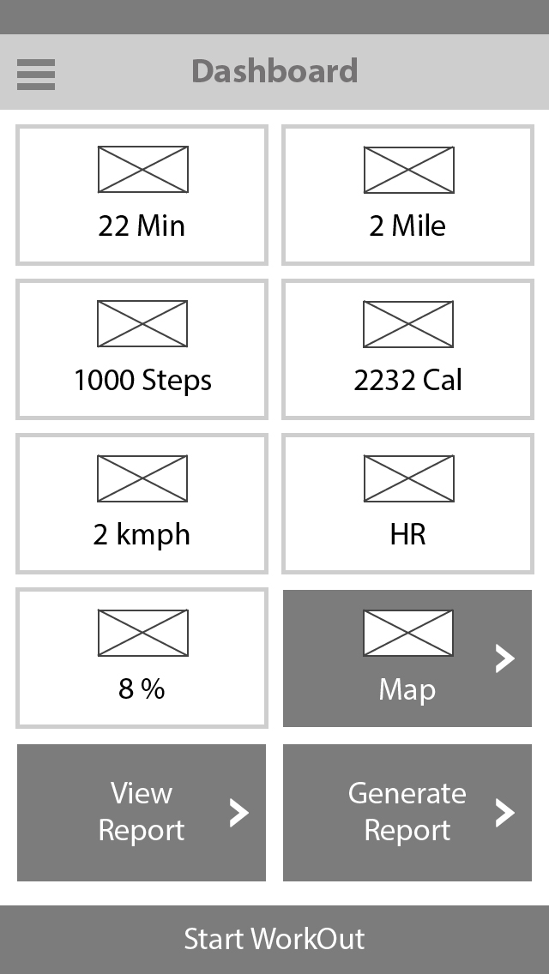

Figure 4.2: Dashboard Wireframe

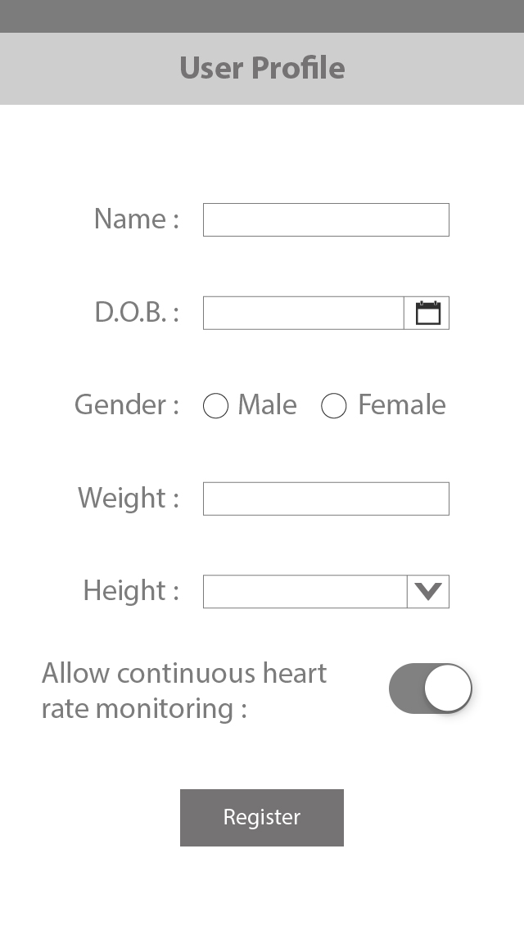

Figure 4.3: User Profile Wireframe

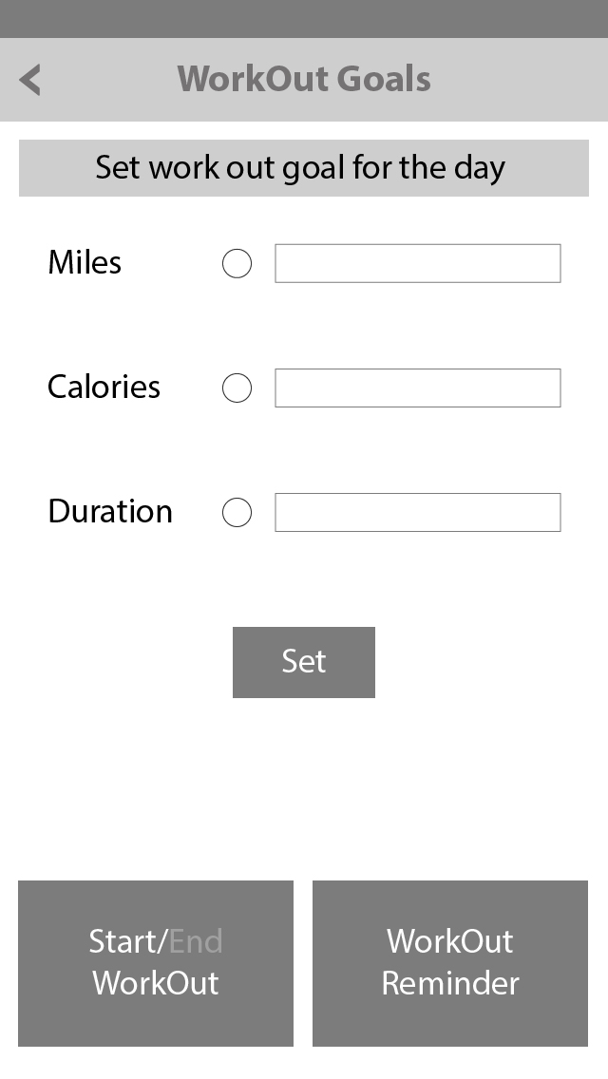

Figure 4.4: Workout Goals Wireframe

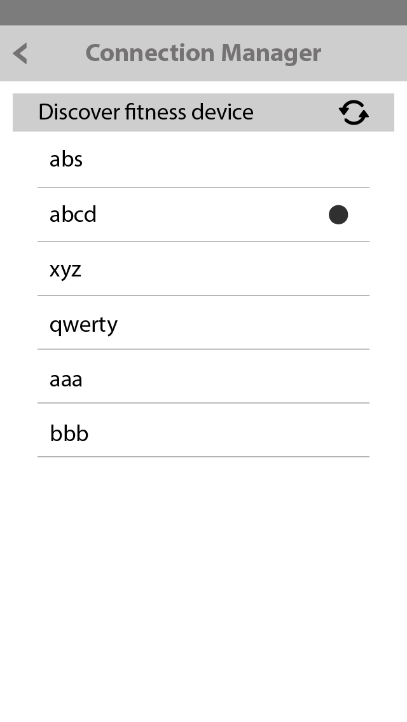

Figure 4.5: Connection Manager Wireframe

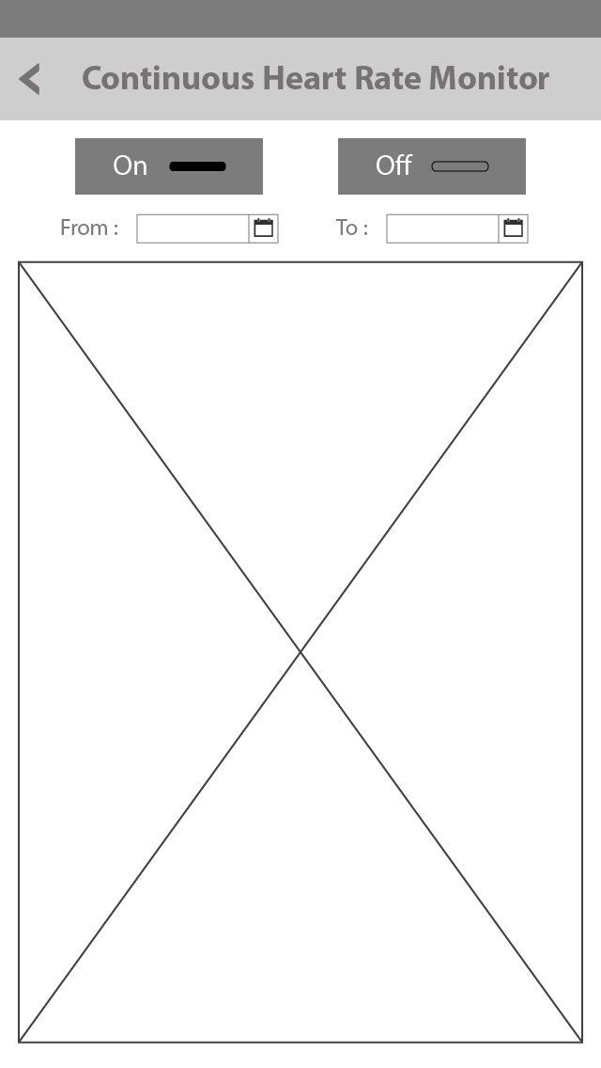

Figure 4.6: HR Monitor Wireframe